|  |  |
| --- | --- |
|  |  |
| **Course:** | All Computing Courses |
| **Sitting:**  **Assessment type:** | Continuous Assessment  Take home practical coding project |
|  |  |
| **Year:**  **Weighting of final grade:** | Year 2 Semester 2; Assessment 2  20% |
|  |  |
| **Due Date:** | Must be submitted online before midnight Friday 15thApril 2015 |
| Module Name: | Database Implementation |
|  |  |
| **Examiners:** | Ms Jacqueline Humphries |
|  | **INSTRUCTIONS**   1. Upload a text file to the course website on Moodle. 2. Include your name in the file name you upload 3. You will be required to explain your query design. 4. Familarise yourself with the Institute policy on PLAGARISM. 5. Please write the SQL code to answer each of the queries, and show the output as a [Print Scrn] image. 6. Each question number, and question should be typed, followed by the SQL code related to that question; then followed by screen capture image of the output. 7. Use the script file to create the Toy Store that has been supplied by your lecturer – do not use your own version created in CA1. 8. Do not copy and paste the script code file from Moodle, instead download the file as a .sql. Open toystore.sql into Workbench, and run the code. If you are asked to convert, choose [Yes]. You may need to run the code in blocks at a time as sometimes the buffers an loose data when reading in a large amount of code. You should check that you have all the correct data to test your code before you start to write your queries. You may need to drop some existing tables if you have some with the same name. |
|  |  |
|  |  |

Before you commence check that you have all the following tables.

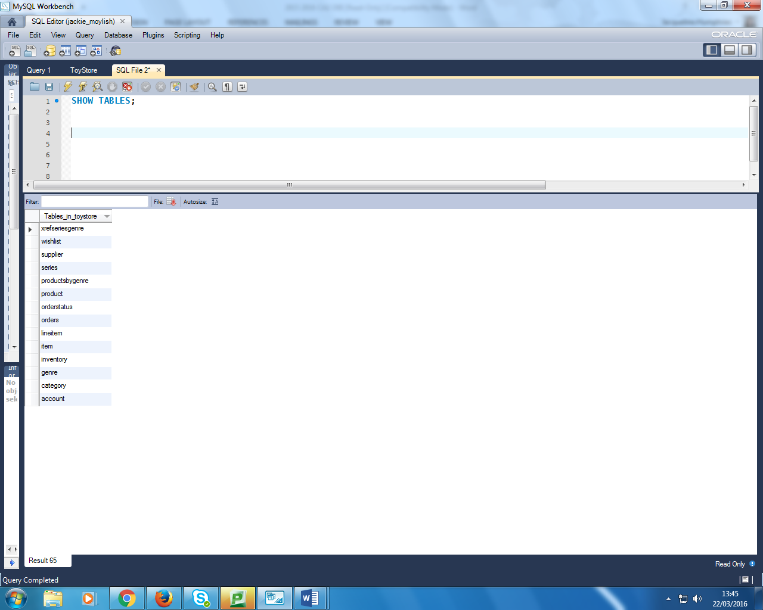

|  |
| --- |
| **TOY STORE – QUERY DESIGN** |

**Question 1 (5 Marks)**

List all order numbers, with the date the order was placed, where date is formatted like the following:-

Order ID Order Date

4 2007, June 17

.... ....

for all orders, sort latest order first.

**Question 2 (10 Marks)**

List all account holders (account.last_name and account.firstname) with their age in years, where the customers name is concatentated as a string. Sort in alphabetical order E.g.

Customer Age

Dwight Gordon 34

.... ....

**Question 3 (5 Marks)**

List all account holders who are using either a yahoo.com or a gmail.com email account. Where all yahoo.com accounts are listed first, followed by all gmail.com accounts, e.g.

Customer Email Domain

Madeline House yahoo.com

.... ....

**Question 4 (10 Marks)**

Calculate the percentage split of female and male account holders, e.g.

Gender % Account Holders

G 52

M 48

**Question 5 (10 Marks)**

Calculate how many orders are placed in each month of the year. You do not need to differentiate by year, i.e. count all the orders placed in January, all placed in February etc e.g.

Month No. Orders Placed

1 67

2 31

3 45

4 66

**Question 6 (10 Marks)**

Calculate the average number of items placed across all orders, .e.g

Average Qty Ordered Per Order

12

**Question 7 (5 Marks)**

List the most popular credit card to pay an order with. E.g

Most Popular Credit Card

Visa

**Question 8 (10 Marks)**

List the name of account holders, the order number , order date, and productId for all orders for any products in the Fate/Stay Night series.

Account Holder OrderNo Order Date ProductID

Lara Daryl 147 2008-11-15 115

.... .... .... ....

**Question 9 (10 Marks)**

Create a view that lists all products and their descriptions, sorted by genre, e.g.

Genre Product Name

Action/Adventure Akira Book 01 (Manga)

.... ....

Note that some products will appear more than once in the list as the product series may fall under many genres.

**Question 10 (10 Marks)**

List each state (account.state_province) for which account holders are registered, with the total value of orders placed within that State. The total price should be rounded to the nearest integer.

State Total Price of Orders within State

CA 543

OH 610

.... ....

**Question 11 (10 Marks)**

List all product numbers, with their list price (selling price), unit price (cost price), and mark-up (% difference profit), where the mark-up between the unit price and what it’s sold for is greater than or equal to the average markup.

Product ID List Price Unit Price Mark-up %

149 19.99 14.99 33

.... ....

**Question 12 (5 Marks)**

List all order numbers, with their order date, and its ‘Expected Delivery Date’ which is calculated as the order-date plus 3 days.

Order No Order Date Expected Delivery Date

12 2008-08-05 2008-08-08

.... .... ....